Part Number: PT938-53140-XX

Kit Contents
Item # | Quantity Reqd. | Description
1 | 1 | Spoiler
2 | 2 | Hardware Bag
Hardware Bag Contents
Item # | Quantity Reqd. | Description
1 | 2 | M6 x 1 – Flange Nut
2 | 2 | Plastic Spacer with Foam
Additional Items Required For Installation
Item # | Quantity Reqd. | Description
1 | 1 | Installation Kit  P/N: PT938-53140-DT
2
3
Conflicts
Recommended Tools
Personal & Vehicle Protection | Notes
Safety Glasses
Blankets
Wrist & Belt Protectors
Masking Tape | 2” wide
Special Tools | Notes
Non-Intrusive IR Temperature Probe/Gun
Installation Tools | Notes
Drill
Twist drill bit | 1/8" (3mm)
Twist drill bit | 23/64” (9.1mm)
Trim Removal Tool
Deburring tool or file
Socket | 10mm deep socket
Scale
Center punch
Torque wrench | Approx 5-50 in-lb range
Special Chemicals | Notes
Sealant | 3M™ Ultra-Pro Body Sealant
Cleaner | VDC Approved Cleaner

General Applicability
Recommended Sequence of Application
Item # | Accessory
1
2
*Mandatory
Vehicle Service Parts (may be required for reassembly)
Item # | Quantity Reqd. | Description
1
2
3
Legend
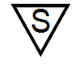
STOP: Damage to the vehicle may occur. Do not proceed until process has been complied with.
OPERATOR SAFETY: Use caution to avoid risk of injury.
CAUTION: A process that must be carefully observed in order to reduce the risk of damage to the accessory/vehicle and to ensure a quality installation.
TOOLS & EQUIPMENT: Used in Figures calls out the specific tools and equipment recommended for this process.
REVISION MARK: This mark highlights a change in installation with respect to previous issue.
SAFETY TORQUE: This mark indicates that torque is related to safety.

Care must be taken when installing this accessory to ensure damage does not occur to the vehicle. The installation of this accessory should follow approved guidelines to ensure a quality installation.

These guidelines can be found in the "Accessory Installation Practices" document.

This document covers such items as:-
- Vehicle Protection (use of covers and blankets, cleaning chemicals, etc.).
- Safety (eye protection, rechecking torque procedure, etc.).
- Vehicle Disassembly/Reassembly (panel removal, part storage, etc.).
- Electrical Component Disassembly/Reassembly (battery disconnection, connector removal, etc.).

Please see your Lexus dealer for a copy of this document.

Prepare the Vehicle.
  - Installation of the rear spoiler should not take place until the following have been completed:
(1) The car is washed.
(2) The trunk and spoiler should be a minimum of 60˚F for proper set-up of adhesive tape. Use a hot air blower to heat the surface if the temperature is below 60˚F.
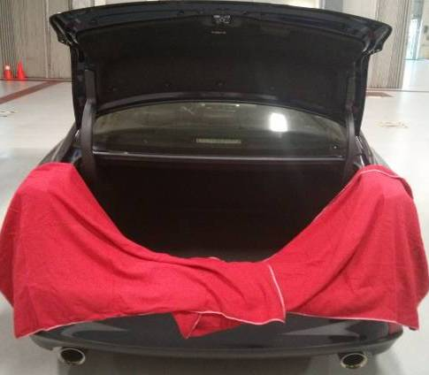
  - Open the trunk lid and place blankets to protect the rear fenders, rear fascia and the inner trunk area (Fig 1-1).
Fig. 1-1

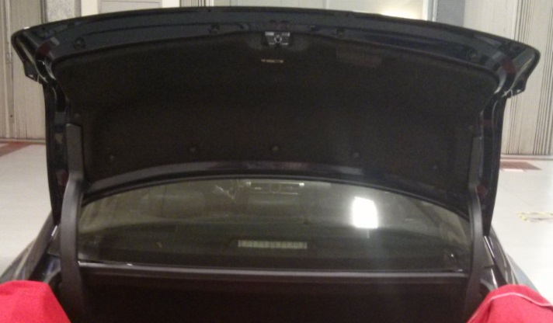
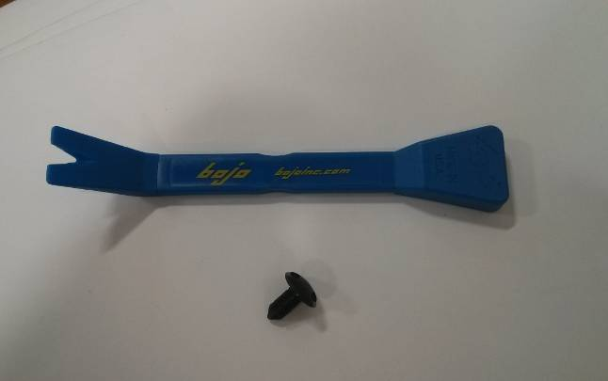
  - Use a trim removal tool (Fig 1-2) to remove the 14 plastic clips securing the interior trunk lid liner to the trunk (Fig 1-3).
Fig. 1-3
Trim removal tool
Fig. 1-2

Install the Mylar Template.
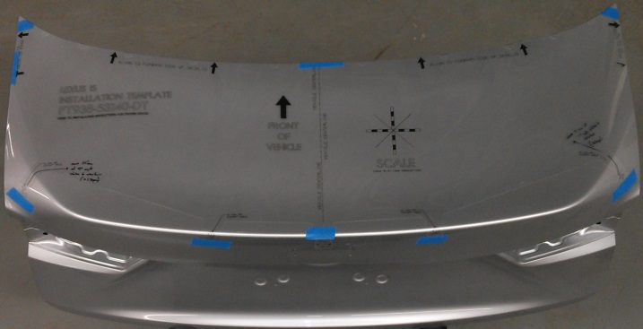
  - Place the installation template (PT938-53140-DT) onto the trunk lid surface with the FRONT arrow pointing toward the front of the vehicle (Fig 2-1).
Fig. 2-1
NOTE: It is very important that the template does not have any wrinkles when it is positioned to ensure the holes are drilled in the proper location. The installation template should lay flat and tight against the vehicle surface.
  - Align the forward edge of the template with the leading edge of the trunk lid (Fig 2-2).
Fig. 2-2

  - Align the template left to right using the template edges by ensuring that the edges indicated with arrows are equidistant from their respective edges. The template also includes a feature above the vehicle emblem to assist in alignment if necessary. The template should be centered left to right on the trunk lid (Fig 2-3).
Fig. 2-3
  - Apply tape to the template such that the template is secured to the trunk lid.
CAUTION: When all tape has been applied, ensure that no shifting of the template occurred by double checking the position of all alignment tabs.
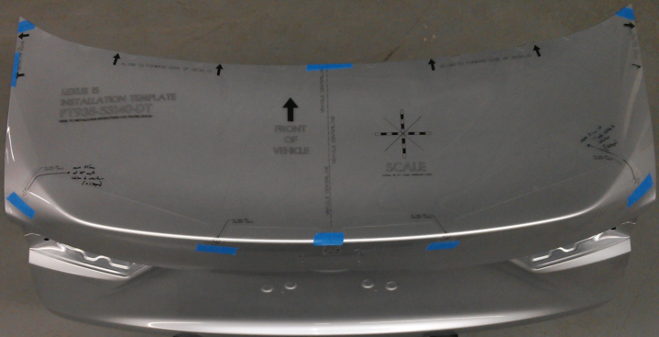
  - Apply tape to the four tabs that contain the cross-hairs for the hole locations (Fig 2-4).
Fig. 2-4

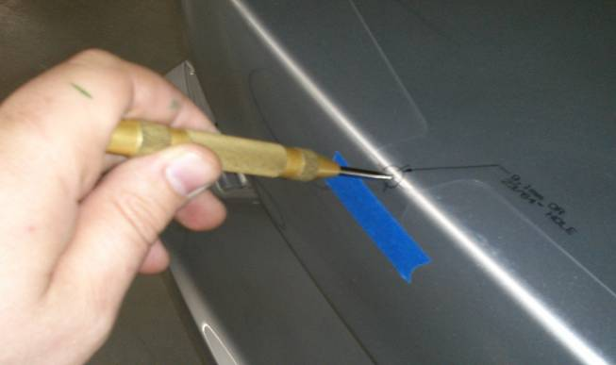
  - Center punch through the installation template at each of the four cross hair locations (Fig. 2-5). This indentation in the deck lid will be used to accurately position the drill bit and prevent the drill bit from “walking”.
Fig. 2-5
Center punch
  - Remove the installation template carefully to ensure the tape does not damage the paint.

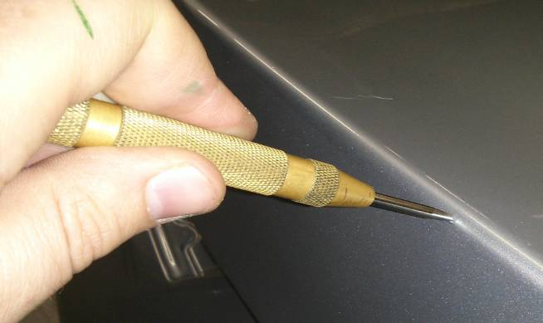
  - If desired, use the center punch to re-punch the hole locations to make the indentation “deeper" (Fig 2-6). This will assist in preventing the drill bit from "walking.”
Fig. 2-6
Center punch

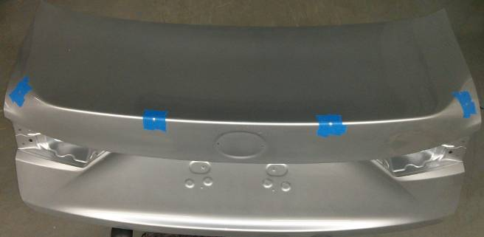
  - Apply tape around each center punched location to protect the paint if the drill bit slips (Fig 2-7).
Fig. 2-7

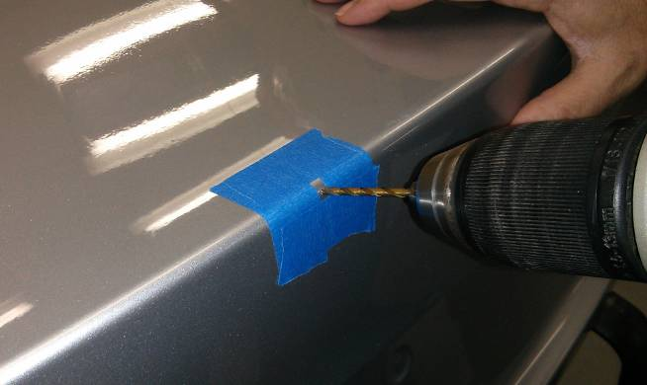
  - Drill a pilot hole at each center punched location using a 3mm (1/8") drill bit (Fig 2-8).
1/8” drill bit
Fig. 2-8
CAUTION: Eye protection must be worn during all hole drilling.
  - Enlarge each drilled hole with a 9.1mm (23/64") drill bit.

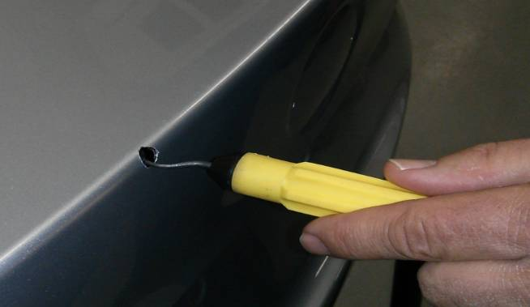
  - Remove the masking tape surrounding the holes and use a de-burring tool or file to remove any burrs on the edges of the drilled holes (Fig 2-9).
Fig. 2-9
Deburring tool
NOTE: It is particularly important to remove all burrs on the outboard holes (inside and outside of trunk lid) because they may prevent the legs of the attachment clip from engaging properly.

Install the Spoiler.
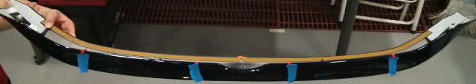
  - Use masking tape to peel back the six tape liners slightly and secure them to the outer perimeter of the spoiler with masking tape (Fig 3-1). This is done to ensure that they do not slip underneath the spoiler during installation.
Fig. 3-1
  - The trunk lid where the spoiler attaches must be cleaned with approved cleaner using a lint free cloth.

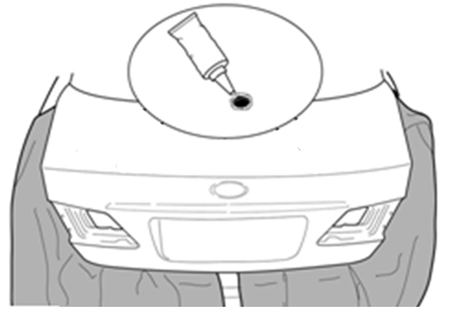
  - After cleaning, carefully apply 3M Ultra Pro Body Sealant to the four holes on the top surface of the trunk lid (Fig 3-2).
Fig. 3-2

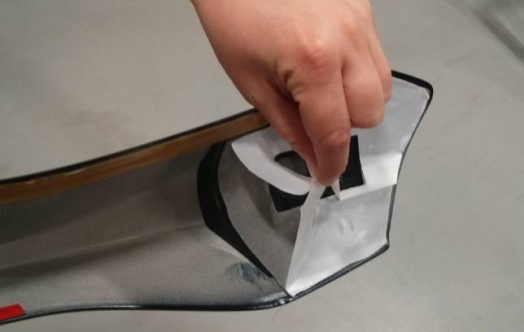
  - Remove the tape liner on the two large pieces of tape on at the outboard tips of the spoiler (Fig 3-3).
Fig. 3-3
NOTE: The outboard attachment clips will prevent the tape at the outboard tips from contacting the trunk lid until they are engaged by pressing downward. Do not push downward on the outboard ends until instructed.

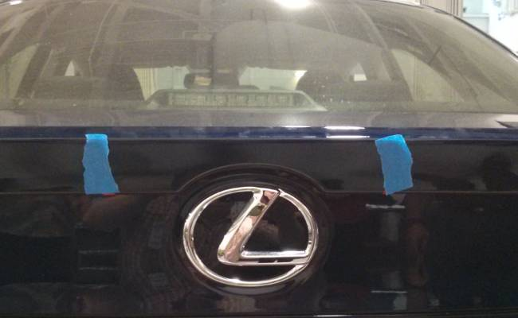
Fig. 3-4a
Center spoiler over emblem
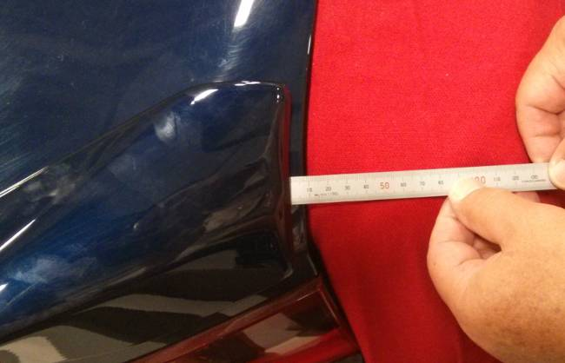
  - Place the spoiler onto the trunk lid and carefully position it so that it is centered left to right on the trunk lid by measuring the distance between spoiler edge and trunk lid each on each side (Fig 3-4a and 3-4b).
Fig. 3-4b
Scale

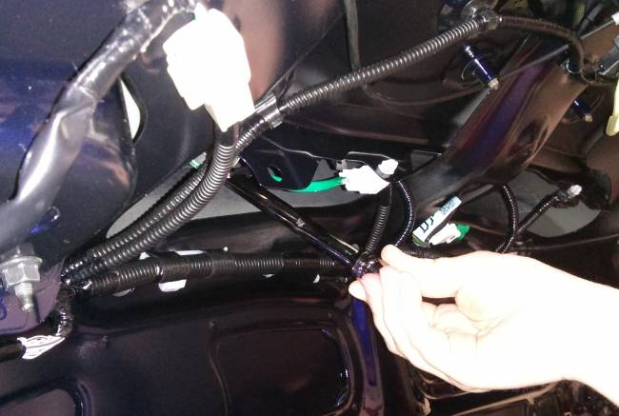
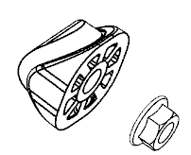
  - While holding the spoiler to prevent it from moving left to right, open the trunk lid and loosely hand the two M6 nuts onto the studs tighten (enough to compress the foam and seat the spoiler to the trunk lid curvature) (Fig 3-5). Note that the plastic spacers with foam are installed between the M6 nuts and the inside of the trunk lid as shown in the inset image.
Fig. 3-5

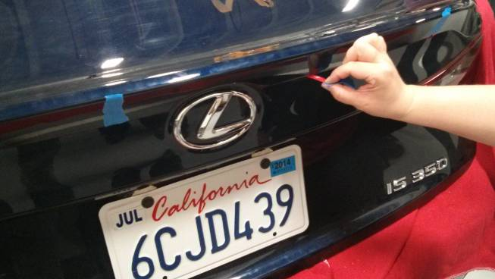
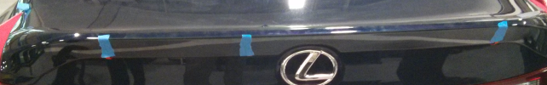
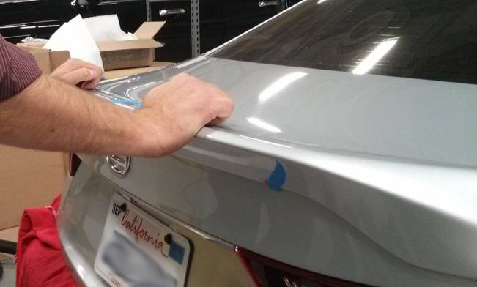
  - Verify that the spoiler is centered to the trunk lid (Fig 3-4a and 3-4b), then push forward and downward on the spoiler (Fig 3-6) and begin removing the tape liners from the rear edge of the spoiler in the sequence shown
(Fig 3-7). Push downward on each tape strip to ensure good wet-out is achieved and the gap between spoiler and trunk lid at the rear edge is minimized.
Fig. 3-7
1
2
3
4
Fig. 3-6
CAUTION: Take care when pulling the tape line from the spoiler edges to prevent tearing of the tape liner.
  - Check the position of the white outboard clips on the spoiler to ensure that they are positioned over the drilled holes. If they are not, use a plastic tool to move them over the drilled holes.
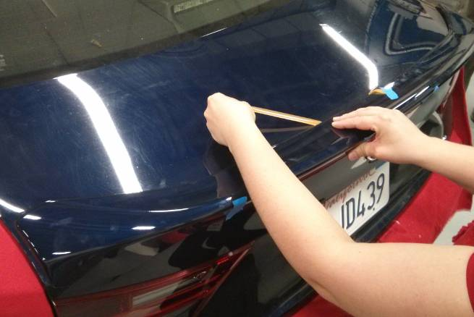
  - Remove the left hand side of the two tape pieces along the leading edge of the spoiler (Fig 3-8) pressing the rear edge of the spoiler forward (Fig 3-8 Arrow 1) and then roll your hand forward to continuously press downward on the top surface of the spoiler (Fig 3-8 Arrow 2) to wet-out the tape. Continue the sequence in this manner, working from the center of the spoiler outward.
1
2
Fig. 3-8

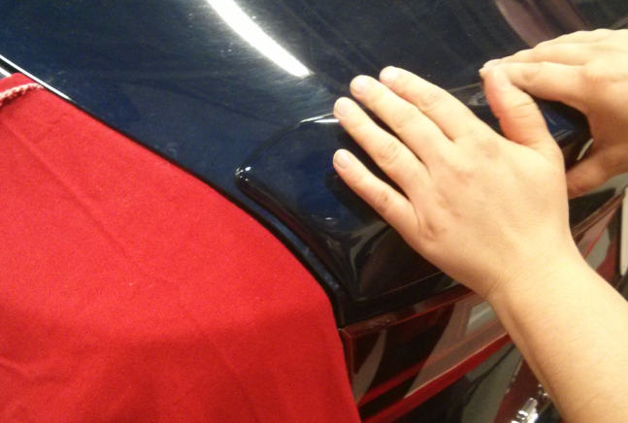
  - Visually align the end of the spoiler such that when the spoiler will be pressed downward it matches the curvature of the trunk lid. The yellow arrow indicates the area best suited for alignment (Fig 3-9). When aligned, beginning at the rear edge (Fig 3-9 Arrow 1) press forward to wet-out the tape and continue rolling the hand forward (Fig 3-9 Arrow 2) to wet-out the outboard tip of the spoiler. As the hand passes the point indicated by the red dot (Fig 3-9) press downward to ensure that the clip engages.
1
2
Fig. 3-9
NOTE: Proper alignment of the spoiler at the ends is critical to ensure good appearance. If the spoiler is out of position such that the edge of the spoiler touches the vehicle, paint damage to the paint may occur.
  - Repeat instructions (i) and (j) for the tape length on the right hand side of center along the leading edge of the spoiler.
  - Open the trunk lid and tighten the two M6 nuts 16 in-lbs (1.8 N-m).
  - Visually inspect the drilled hole areas for any signs of metal shavings. Remove if found.
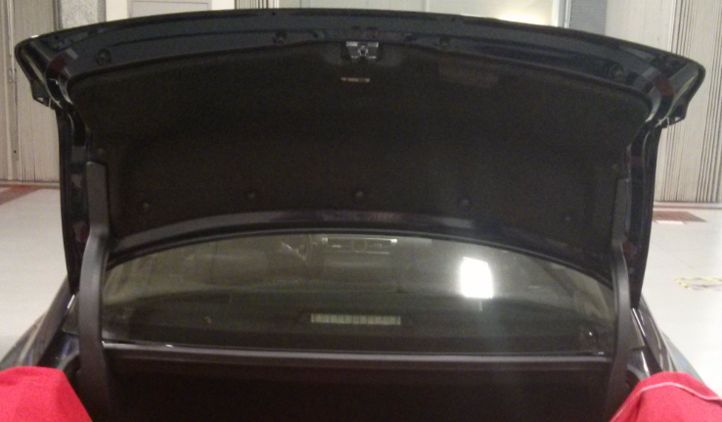
  - Reinstall the inner trunk lid liner by reinstalling the 14 clips removed in Step 1(c)
(Fig 3-10).
Fig. 3-10
  - Close the trunk lid and apply pressure to the topside of the spoiler a second time to ensure all of the tape is adhered to the trunk lid.

Accessory Function Checks
Check for visual alignment
Check for full tape adhesion

Vehicle Function Checks
Verify trunk lid operation.

Verify Emergency Trunk Release Handle operation.

The spoiler should appear visually centered on the vehicle.
Full adhesion of tape.

When opened, the trunk lid should initially pop up slightly and remain in the fully raised position when opened fully.

Emergency Trunk Release Handle operates correctly. (With the trunk lid in the open position, trip the trunk lock closed using a nylon pry tool. Pull the emergency trunk release handle and verify the trunk lock has opened.)

Vehicle Appearance Check
After accessory installation and removal of protective cover(s), perform a visual inspection.

Ensure no damage (including scuffs and scratches) was caused during the installation process.
(For PPO installations, refer to TMS Accessory Quality Shipping Standard.)

